6

1. Untitled Scene

1.1 Title 1


1.2 Tabs Bottom Interaction
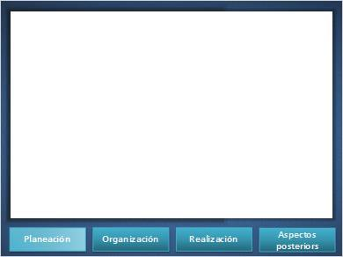

Tab 1 (Slide Layer)
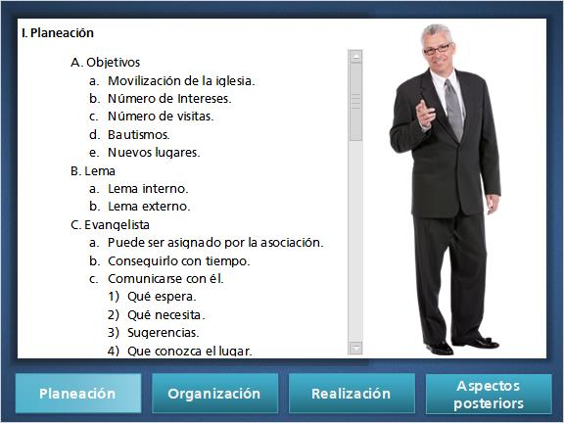

Tab 2 (Slide Layer)
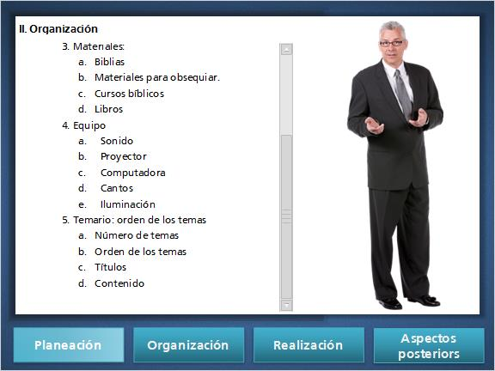

Tab 3 (Slide Layer)
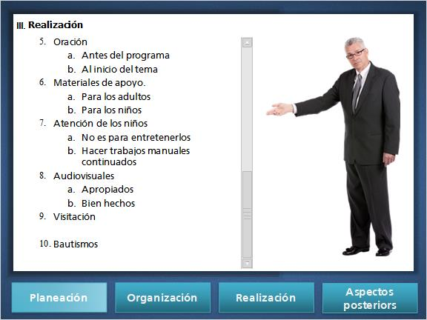

Tab 4 (Slide Layer)
